This is How the Paper Title Should be Written

John White¹, Karl Zucrow², and T. Anderson³

¹Department of Mechanical Engineering, NIT Calicut, Kerala-673601, India
²Department of Applied Mechanics, IIT Delhi, New Delhi-110016, India
³Department of Chemical Engineering, NIT Calicut, Kerala-673601, India

ABSTRACT
Write your abstract here in 10-point Times New Roman. Limit the abstract within 200 words. The whole manuscript should be limited to 5-6 pages.

Keywords: Write five keywords here in 10-point Times New Roman.

INTRODUCTION
Write your introduction section here in 10-point Times New Roman. The introduction part should give the necessary background / motivation behind the work. The citations of others’ work may be bracketed [1-4] appropriately.

LITERATURE REVIEW AND OBJECTIVE
This subsection should contain the literature review and the objective of the work undertaken. Write text matter here in 10-point Times New Roman. Necessary citations may be bracketed [5-8] appropriately.

$$x=\frac{-b±\sqrt{b^{2}-4ac}}{2a}$$ | (1)

MATERIALS AND METHODS
Write your texts here in 10-point Times New Roman. This part should contain the necessary matters related to computational, experimental and analytical investigations. Necessary citations may be bracketed [9, 10] appropriately. All Figures and Tables are to be cited within the text. The Figure/Table captions must be written in Times New Roman 9 point, bold. The Figure caption should appear at the bottom of the Figure, while the Table caption should appear on top of the Table.

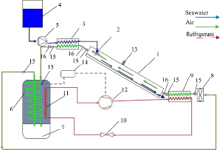
Figure 1: Schematic diagram of the set-up
Table 1: Accuracy of aerodynamic independent variables
Independent Variables | Accuracy
Combined Rotor torque (T_{rotor}) | $$±1\%$$
Angular velocity of combined rotor $(ω$) | $$±2\%$$
(As indicated above, all the notations are to be italicized and be written in 10 Point Times New Roman)

  - Subtitle
Write text matter here in 10-point Times New Roman.

RESULTS AND DISCUSSION
The analysis of results is to be written here in 10-point Times New Roman. All Figures are to be cited within the text. Results obtained may be compared with the published data wherever applicable/possible through necessary citations in bracketed form [11, 12].

  - Subtitle
Write text matter here in 10-point Times New Roman. All Figures are to be cited within the texts.

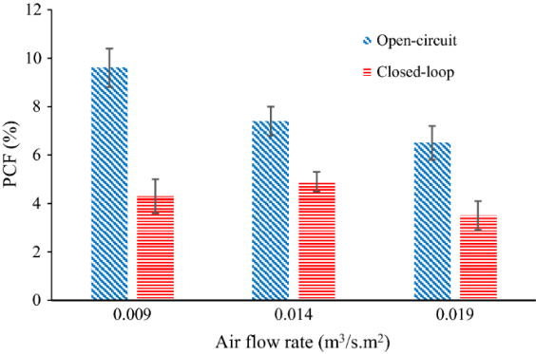
Figure 2: Variation of PCF with air flow rate

CONCLUSIONS
The key findings of the work are to be placed here in 10-point Times New Roman. The conclusion part should be qualitative and quantitative.

ACKNOWLEDGEMENTS
Place any acknowledgements here in 10-point Times New Roman.
NOMENCLATURE
A | Frontal area of rotor | [m²]
AR | Aspect ratio | --
C_{D} | Drag coefficient | --
α | Angle of attack | (ᵒ)
ρ | Density of air | [kg/m³]
ω | Rotor rotational speed | [rad/s]
(As indicated above, all the notations are to be italicized and be written in 10 Point Times New Roman)

REFERENCES
- T. Ogawa, H. Yoshida, and Y. Yokota, Development of Rotational Speed Control Systems for a Savonius-type Wind Turbine, ASME Journal of Fluids Engineering, 111(1), 1989, p. 53. (All the references are to be written in 10-Point Times New Roman, unbold)
- C. D. Rakopoulos, and E. G. Giakoumis, Second-Law Analyses Applied to Internal Combustion Engine Operation, Progress in Energy and Combustion Science, 32(1), 2006, pp. 2-47.
- M. Eswaran, Waves Simulation in an Excited Cylindrical Tank Using σ-transformation, Paper No. IMECE2010–39752, ASME International Mechanical Engineering Congress and Exposition, November 12–18, 2010, Vancouver, Canada.
- K. M. Hussain, Aerodynamic Performance Evaluation of a Novel Turbine, PhD thesis, Department of Mechanical Engineering, IIT Guwahati, India, 2016.
- ANSYS Inc, ANSYS Fluent Theory Guide 12.0, 2015.
- F. M. White, Fluid Mechanics, McGraw-Hills, New York, USA, 2011.

